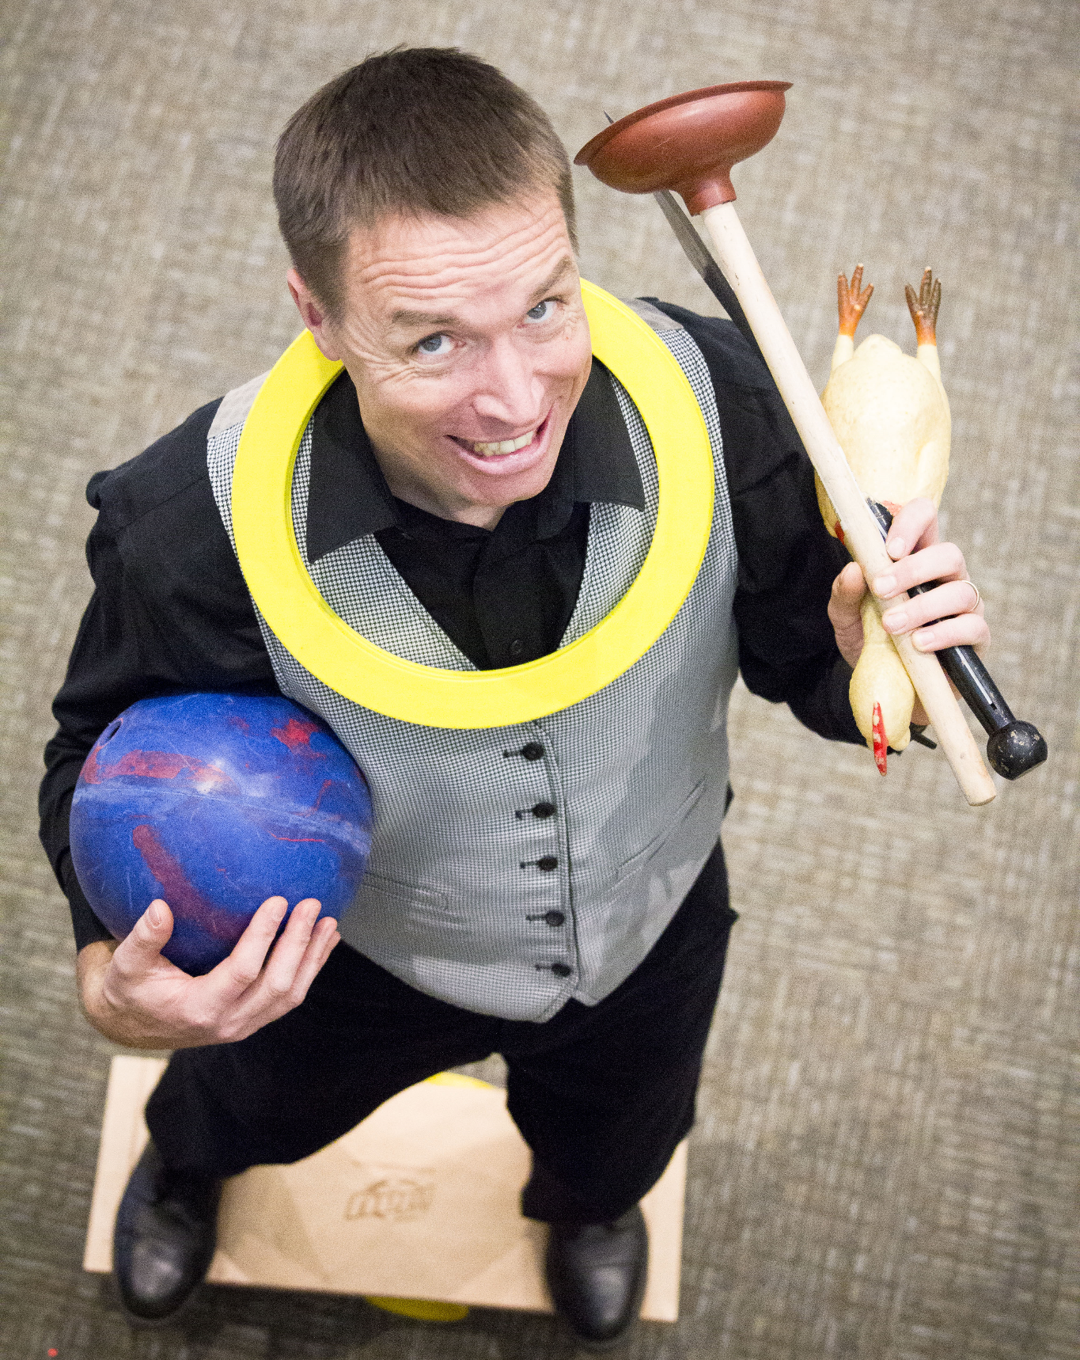
Luke Winger
Juggler & Inspirational
Speaker

Luke began entertaining audiences at just 8 years old and, since then, he has been seen in prisons, churches, schools, festivals, fairs, camps, weddings, and in special events around the globe. He has touched the lives of many through his audience engagement and inspiring messages.
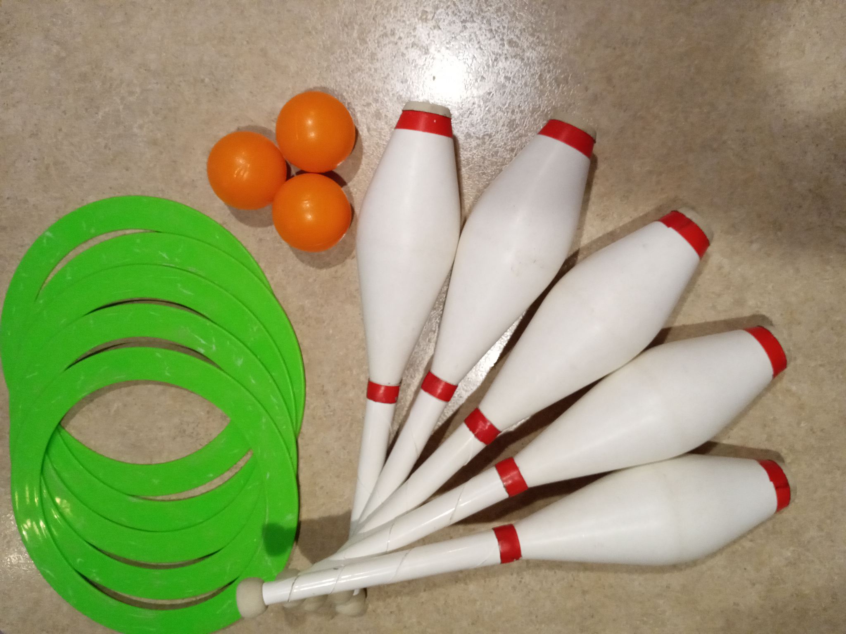
Luke uses his experiences learned from 4 years living in China, 25 years as a nationally competitive cyclist, having an Argentinian wife, raising 5 children, and losing a daughter, and blends them with his juggling and balancing skills to entertain, encourage and inspire people to grow in their relationship with Jesus Christ.
(NAME OF EVENT)
(DATE)
(TIME)
(LOCATION)

